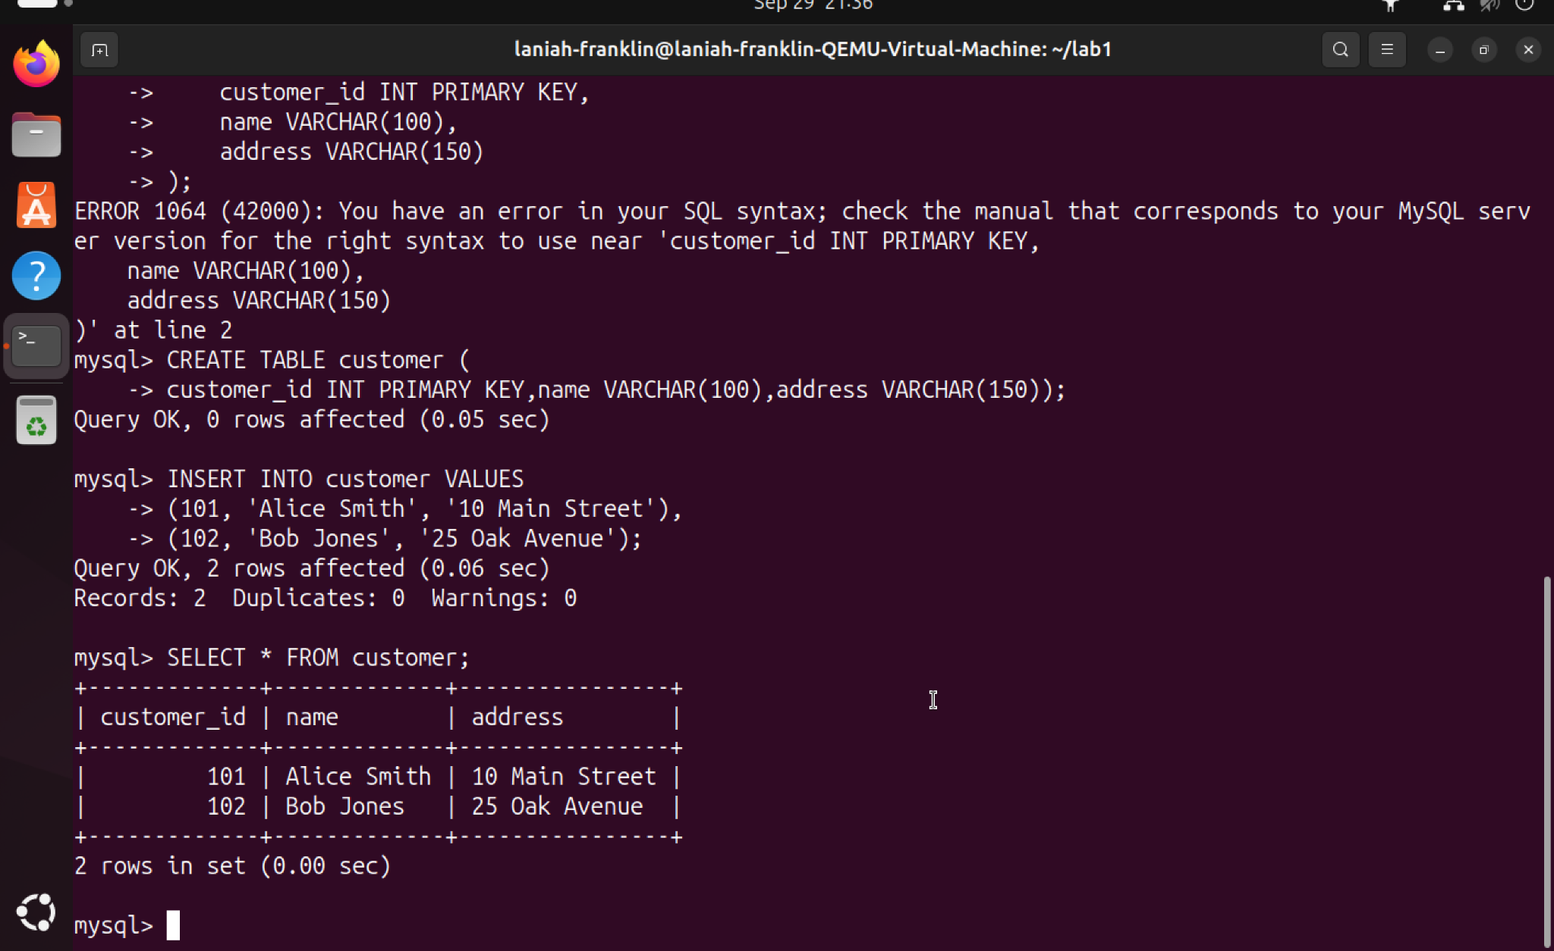

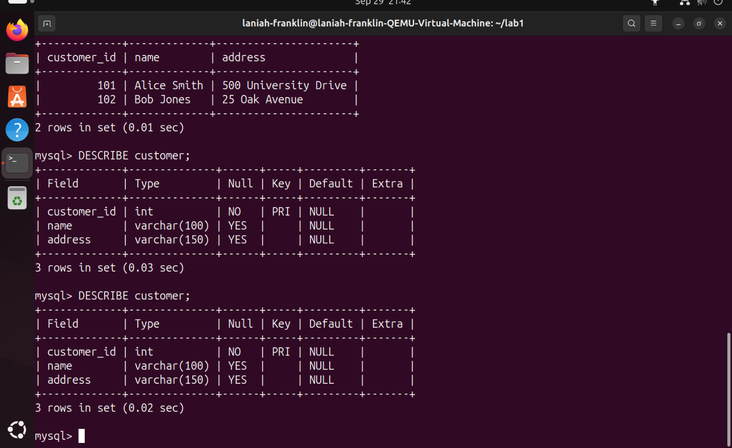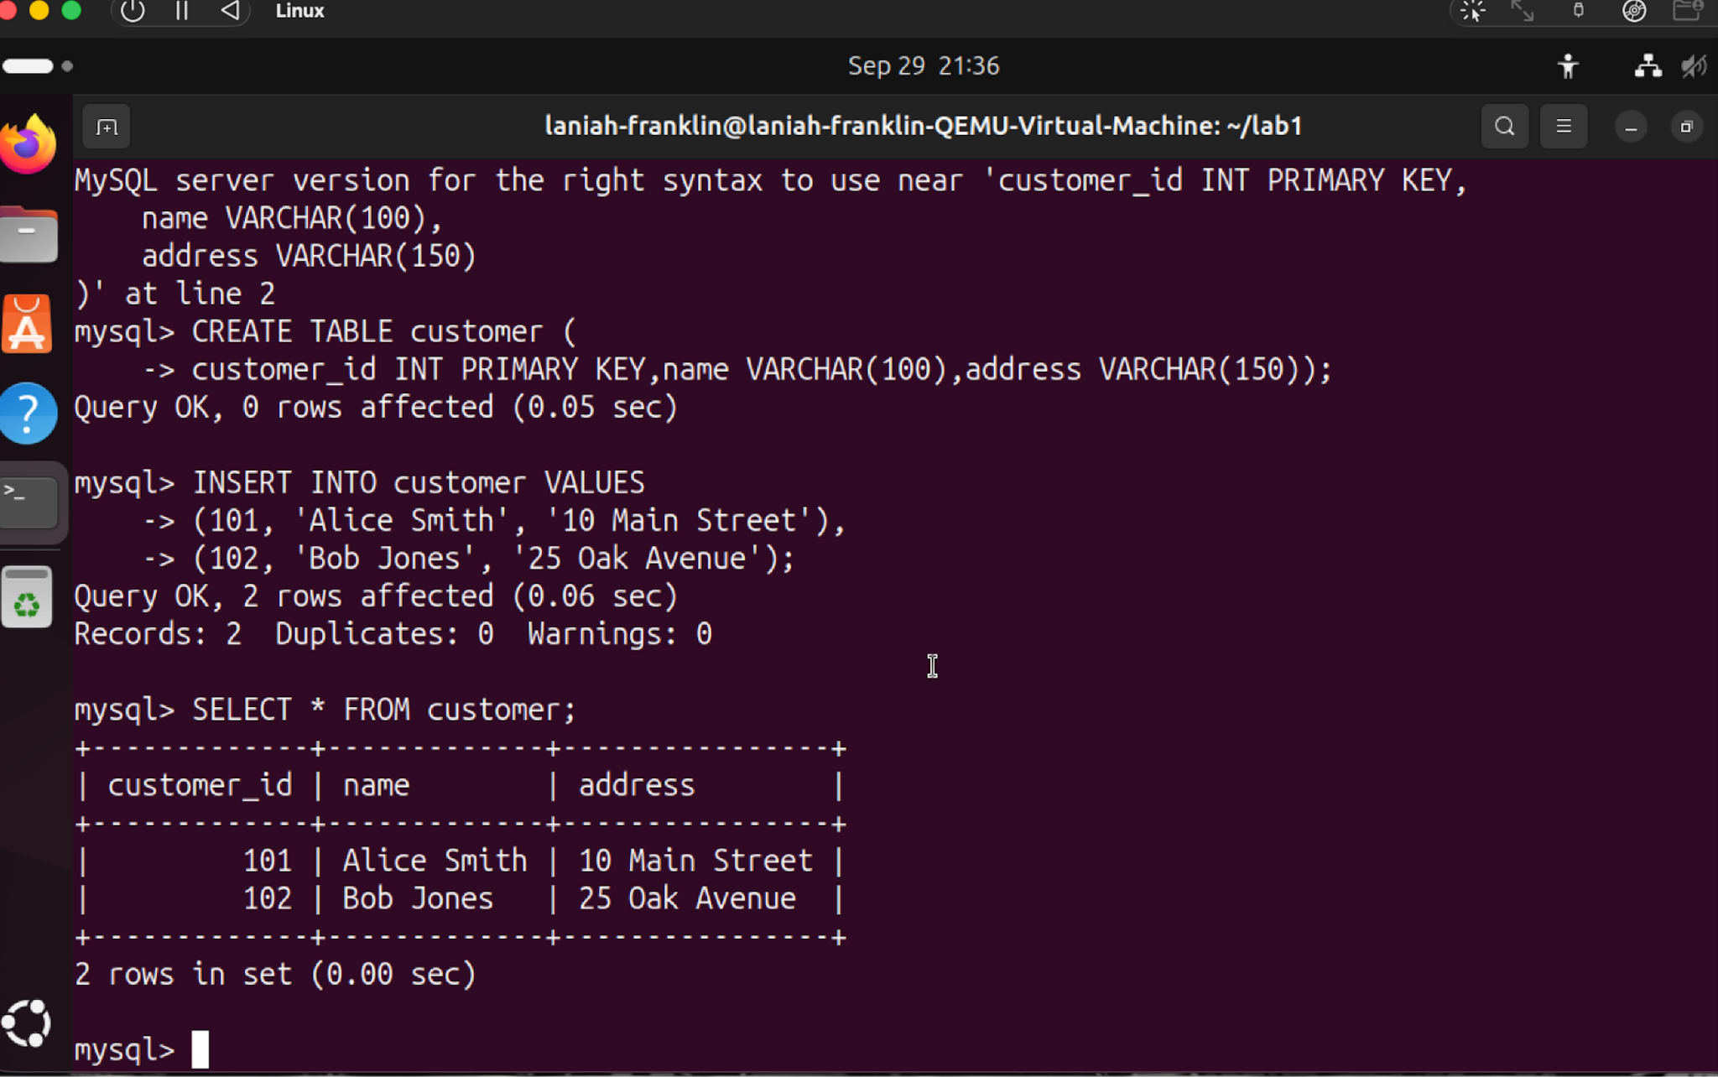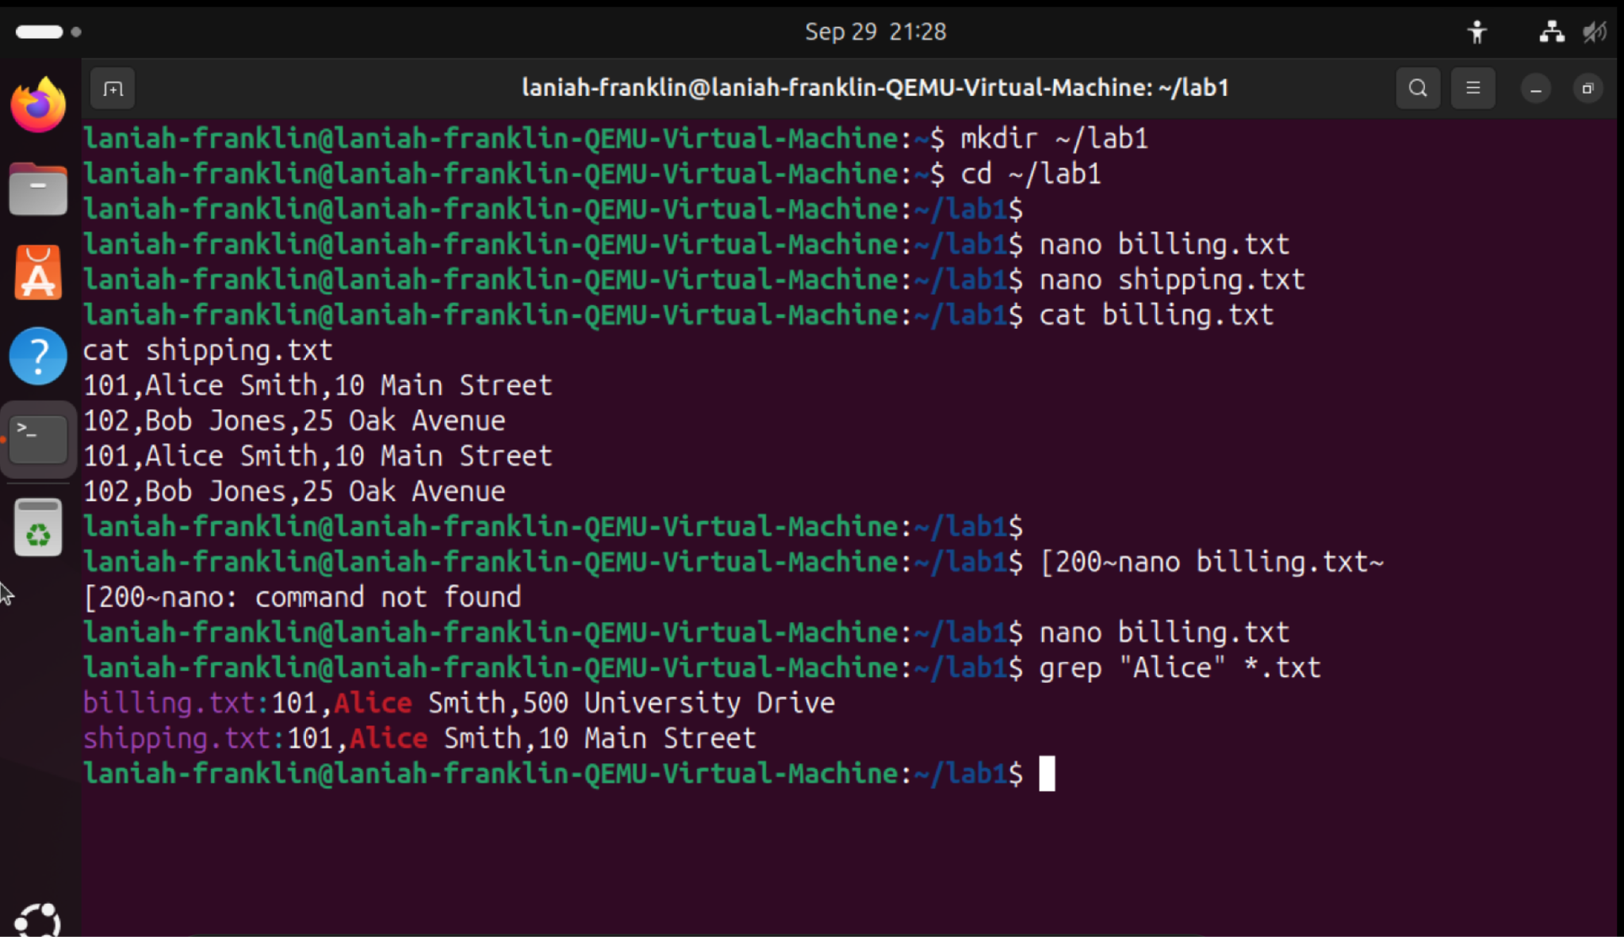

Question 1- the customer id, customer name and the addresses are duplicated in the billing and shipping files.

Question 2- the files files are inconsistent because Alice’s addressed changed in the billing.txt but her other address was still in shipping.txt

Question 3- the problem is the information was stored in more than one file so when changing one of the files, the other doesnt update.

Question 4- the database base stored the data while the DBMS is the software that's used in order to manage the database.

Question 5- 1 record

For Question 6- the database keeps customers information in a single shared space.

Question 7- it shows shows the structure that's in the customer table

Question 8- its considered metadata because its data that is about data

